Name Aoun Muhammad

Roll No 045

Lab 09

**Removing stop words with NLTK in Python**

import nltk

from nltk.corpus import stopwords

nltk.download('stopwords')

print(stopwords.words('english'))

out put

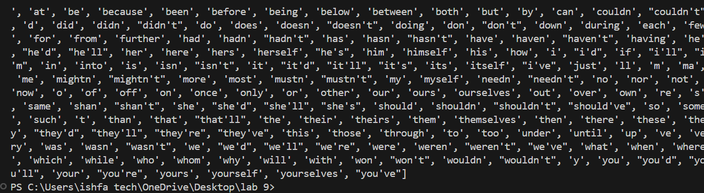

from nltk.corpus import stopwords

from nltk.tokenize import word_tokenize

example_sent = """This is a sample sentence,

                showing off the stop words filtration."""

stop_words = set(stopwords.words('english'))

word_tokens = word_tokenize(example_sent)

filtered_sentence = [w for w in word_tokens if not w.lower() in stop_words]

filtered_sentence = []

for w in word_tokens:

    if w not in stop_words:

        filtered_sentence.append(w)

print(word_tokens)

print(filtered_sentence)

output

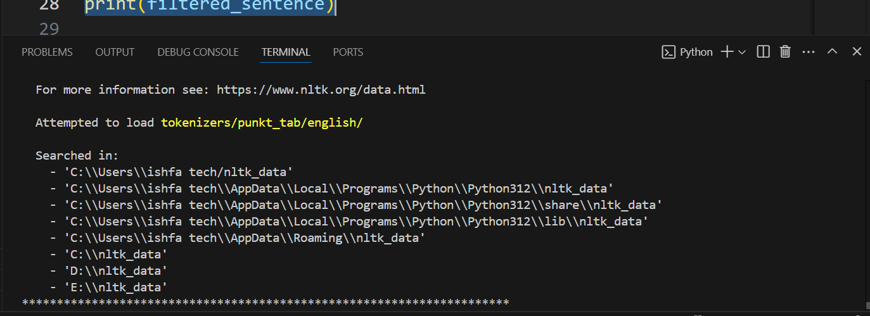

Checking English Stopwords List

from nltk.corpus import stopwords

from nltk.tokenize import word_tokenize

example_sent = """This is a sample sentence,

                showing off the stop words filtration."""

stop_words = set(stopwords.words('english'))

word_tokens = word_tokenize(example_sent)

filtered_sentence = [w for w in word_tokens if not w.lower() in stop_words]

filtered_sentence = []

for w in word_tokens:

    if w not in stop_words:

        filtered_sentence.append(w)

print(word_tokens)

print(filtered_sentence)

output

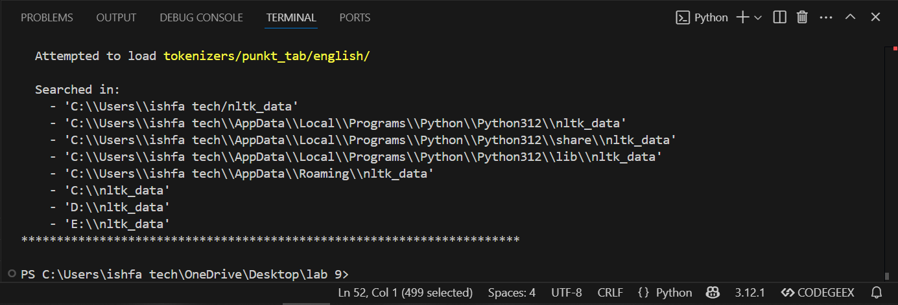

* [Removing stop words with NLTK](https://www.geeksforgeeks.org/removing-stop-words-nltk-python/#removing-stop-words-with-nltk)
* from nltk.corpus import stopwords
* from nltk.tokenize import word_tokenize
* example_sent = """This is a sample sentence,
* showing off the stop words filtration."""
* stop_words = set(stopwords.words('english'))
* word_tokens = word_tokenize(example_sent)
* filtered_sentence = [w for w in word_tokens if not w.lower() in stop_words]
* #with no lower case conversion
* filtered_sentence = []
* for w in word_tokens:
* if w not in stop_words:
* filtered_sentence.append(w)
* print(word_tokens)
* print(filtered_sentence)

out put

